

**FACULTY OF COMPUTING**

**SESSION (2023-2024)**

**Semester:1**

**Assignment 1 : Data analysis using Google Sheets (CS 2)**

**Course :** Big Data Management

**Course code :** MCSD1123

**Lecturer :** Prof. Madya. Ts. Dr. Mohd Shahizan bin Othman

| **Members** | **Matric No.** |
| --- | --- |
| MOHAMMED RAZA A. CHIDIMAR | MCS231004 |
| AYAZ RAHMAN BHUIYAN | MCS231023 |
| MUSAB IBNE AHMAD | MCS231017 |
| HUSSEIN YUSUF SHEIKH MOHAMED | MCS231024 |

**Introduction:**

This report presents a focused analysis of sales performance using a detailed dataset, as outlined in our case study. Our goal is to create an easy-to-use, interactive dashboard in Google Sheets that showcases key sales metrics across different products, regions, and time periods. We will walk through the steps of setting up the dashboard, emphasising its ability to filter and highlight specific data points, such as individual product sales in a particular year or a salesperson's performance. This approach aims to make complex sales data more accessible and understandable, aiding in better decision-making. In summary, this report demonstrates the power of data visualisation insimplifying and interpreting sales data for strategic insights.

**Data Processing & Designing the Dashboard:**

1. A Google Excel sheet was created, and the data from case study 2 (dataset2.txt) was imported there. After that, the Excel sheet link was shared between our team members to work and collaborate together.

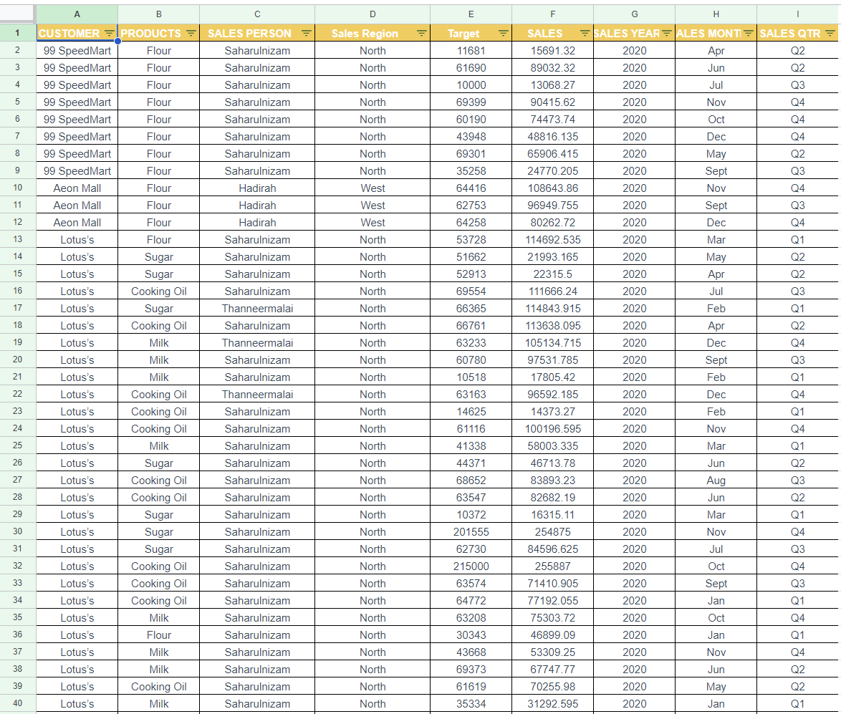

2. Creating a dashboard similar to the figure 7 mentioned in the case study 2 pdf file:

* We start by getting our data ready in Excel or Google Sheets. We make sure everything is in the right format, like dates and sales numbers. Then, we create pivot tables to organize our data. This means making a table for each type of sales data, like sales by product or region. We do this by picking the data we need and making a pivot table where we sort our data into rows and values.

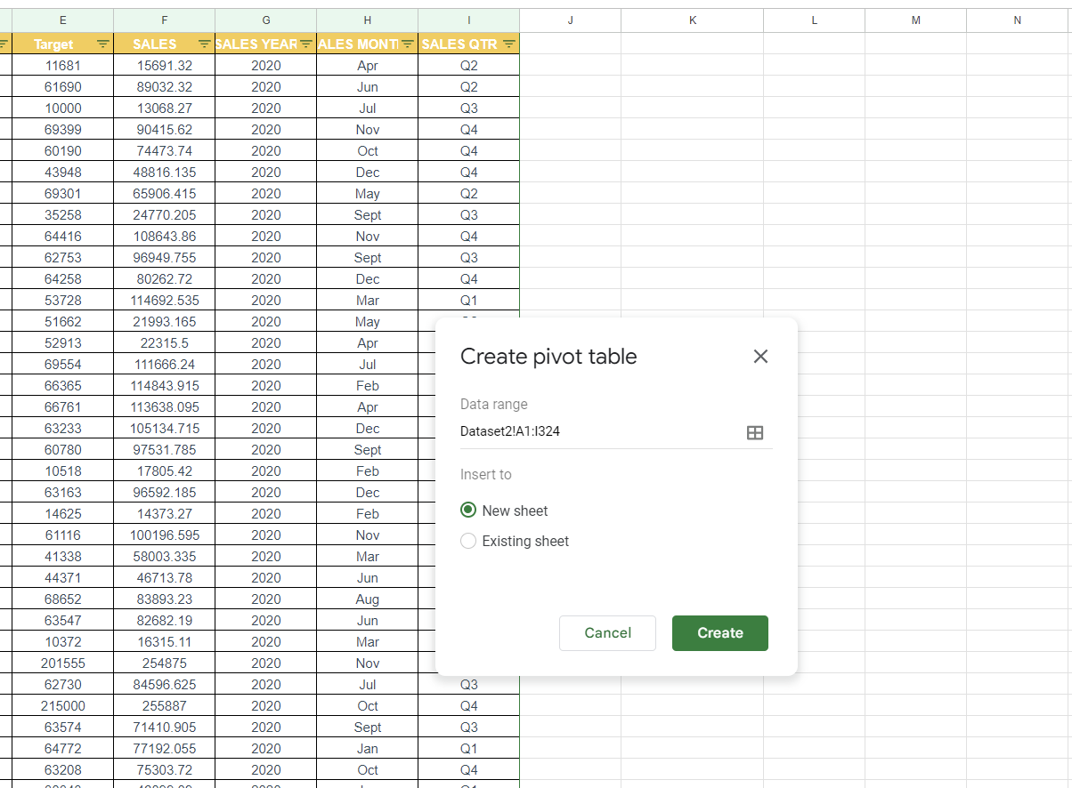

* Next, we make charts for each pivot table. We pick the best type of chart for our data, like bar charts for product sales, to make it easy to understand. We also add slicers in Excel, which are tools that let us quickly see different parts of our data, like sales in a specific year or region.

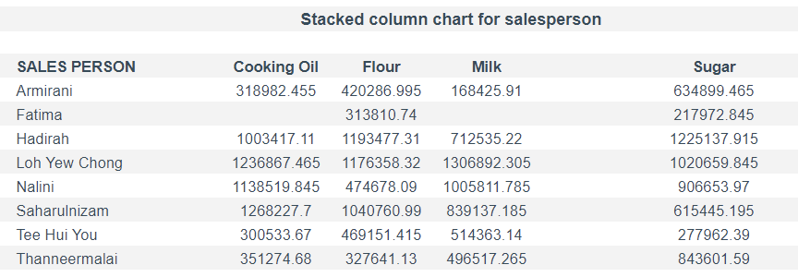

* The design part is important too. We put all our charts and slicers on one sheet in a neat and clear way. We make sure everything is labeled so it's easy to read.
* We then check everything works right, especially the slicers, and make our charts look nice. Finally, when our dashboard looks good and works well, we save it. We can also lock it to stop any accidental changes. This way, we end up with a simple, useful dashboard that helps us see our sales data clearly and make good decisions.

Pie Charts for Region & Customer:

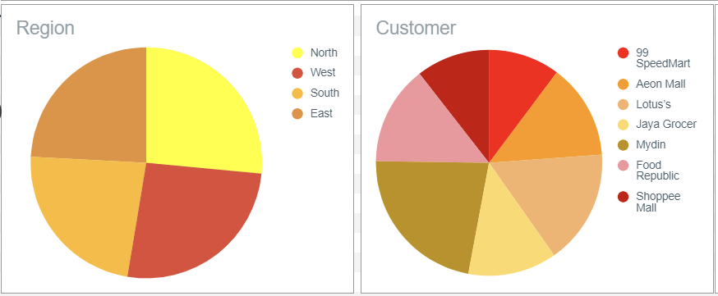

Figure: Simple pie charts to show regional and consumer insights

Pivot Charts for Product Sales:

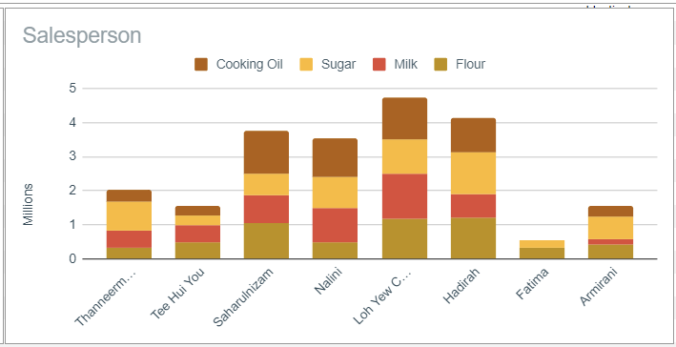

Figure: We analyzed the sales product data using stacked charts to understand which products sellers sold and at what volumes. Stacking provided a clear distinction between seller, product, and sales volume.

Line Charts for Analysing Sales Trends:

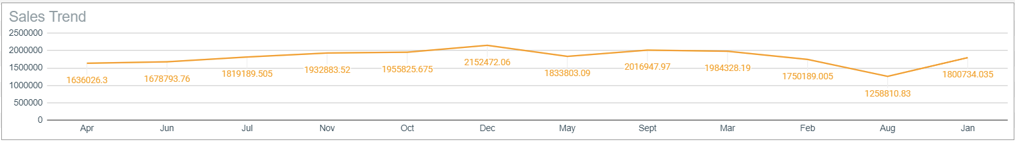

Figure: Line charts were used to analyse sales trends. These charts showed sales patterns and the market's volatility

Sales vs. Target Comparison Chart:

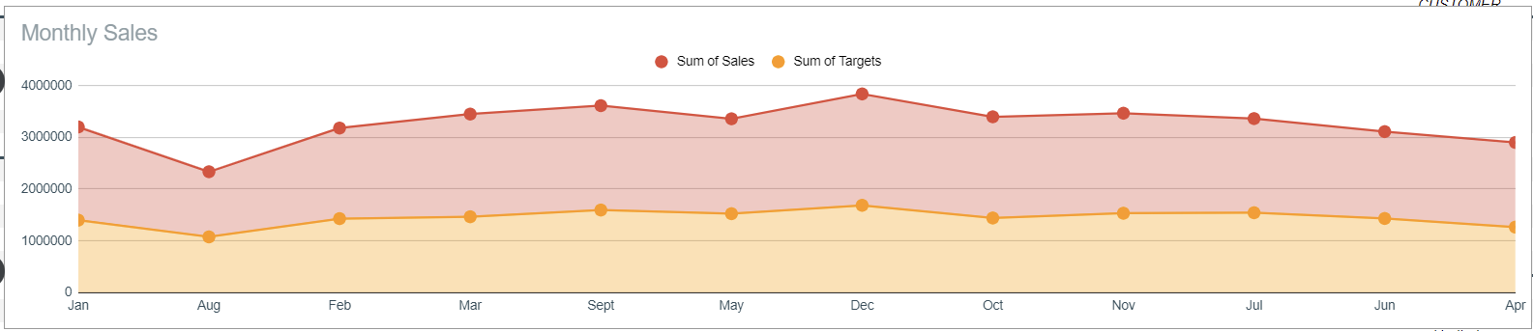

Figure: To provide a clear distinction between actual sales and target sales, a comparison chart was created to go along with the line chart.

3. Interconnected Menus: Choosing a salesperson, like Loh Yew Chong, updates all charts to show their data (refer to Figure 8):

At first, we made pivot tables for our sales data, like sales by product and region. Then, we made charts from these tables to see the data better. Then we added filters to the pivot tables. This means you can click and choose to see only certain data, like sales for one salesperson. When we use a filter on the table, the charts change too. So, if you pick a salesperson, the charts show just their sales. After that, we put all these tables and charts in a clear way on one sheet. This makes it easy to see everything. Lastly, we have checked to make sure if everything worked correctly. We also changed the filters to see if the charts updated right.

**Final Output:**

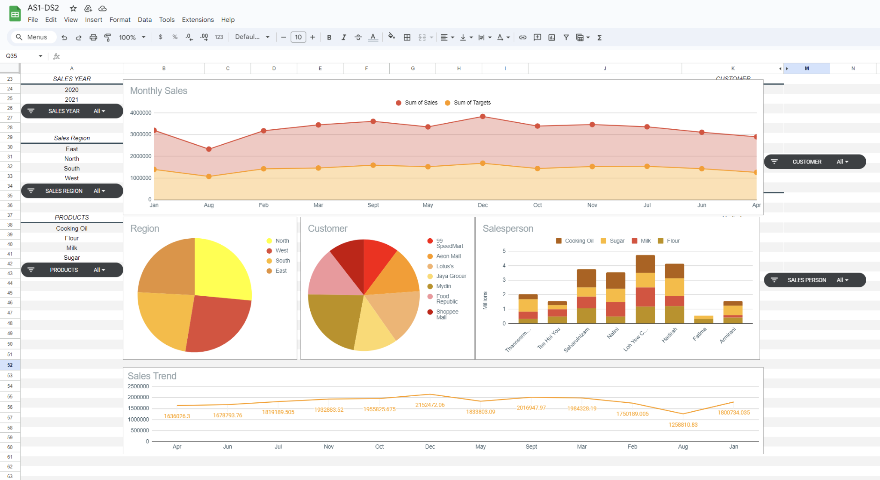

Figure: A fina overview of the dashboard layout

**Conclusion:**

In summary, this case study challenges us to create a dynamic sales performance dashboard using the "dataset2.txt" dataset and Google Sheets. It emphasizes the importance of effective data visualization and interactivity.

Key points include understanding the dataset, designing an interconnected dashboard with menus, and utilizing various charts for insights. The case study provides a practical opportunity to apply data analysis skills in a real-world context, enhancing our ability to make informed decisions in sales performance analysis. For specific questions or guidance, please don't hesitate to reach out.